Assignment 1

Q1: Where is the DDR register located for each port?
- DDRA = 0x1A
- DDRB = 0x17
- DDRC = 0x14
- DDRD = 0x11
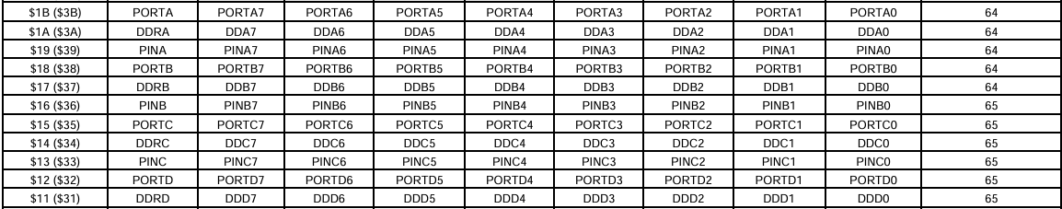

Q2: SRAM vs Flash

Feature | SRAM | Flash
Type | Volatile memory | Non-volatile memory
Data after power off | Lost | Stored permanently
Main use | Store variables during program execution | Store the program code
Speed | Faster | Slower than SRAM

